STATE HIGH SCHOOL

BIOLOGY: Individual activity booklet

EXTENDED EXPERIMENTAL
INVESTIGATION STUDENT LEARNING JOURNAL AND INVESTIGATION SCAFFOLD RESOURCE

EXPERIMENTAL ECOLOGICAL FIELD STUDY MANUAL:
NORTH KEPPEL ISLAND

STUDENT NAME: _____________________________

Contents | PAGE
Intro to research station | 3
Your responsibilities | 5
Safety & First Aid | 6
Dangerous reef creatures | 8
INDIVIDUAL ACTIVITIES
A. Following a friendly fish | 13
B. Introductory nocturnal studies | 16

Wed 28 |  | Thu 29 |  | Fri 30 |  | Sat 31
Time | Ht | Time | Ht | Time | Ht | Time | Ht
0234 | 3.49 | 0341 | 3.51 | 0444 | 3.55 | 0545 | 3.57
0918 | 1.31 | 1021 | 1.13 | 1118 | 0.93 | 1211 | 0.74
1528 | 3.05 | 1636 | 3.31 | 1737 | 3.63 | 1831 | 3.94
2114 | 1.58 | 2236 | 1.45 | 2346 | 1.24

Schedule overview.

Wednesday | AM | * Meet at North Keppel cat by 10am
Wednesday | PM | - Arrive and set up.  - Station orientation and safety induction inc. snorkel safety  - Intro reef walk
Thursday | AM | Low water activities in group booklet. Start EEI
Thursday | PM | High water snorkel on reef flat + EEI
Friday | AM | EEI
Friday | PM | EEI + Boat snorkel to blue hole

Saturday | AM | Pack up, clean cabins, take gear to wharf ready for departure
Saturday | PM | Home
Introductory talk for Nth Keppel
.
1. The whole island is a National Park surrounded by Marine Park
- Respect and care for all Flora & Fauna. This also means strictly no feeding of the birds.
- Stay on island paths as shearwater nests are easily damaged (if collapsed please dig nest out)
- Care when reef walking. Stay to sand trails and corals should never be walked on.
- Only snorkel on reef flat in buddy pairs. Always tell someone where you are and when you will be back.
- No torches or flash photography at night during turtle nesting and hatchling seasons as lights confuse turtles.
- Rubbish must be placed in correct recycling bins or fines apply.
- No collecting except by Permit. Removal of any plant or animal by an individual or group can attract fines in the order of $20000.
- Turn off lights (not only saves on power but lights confuse nesting and hatching turtles).

2. Kitchen. ·
- Cutlery and crockery should not to be removed from this general area. ·
- Put FOOD SCRAPS in plastic bags before putting in large bins. ·
- All other waste to be placed in specific recycle bins. ·
- No fats, oils or solids are to be placed down sinks. Please use containers provided in kitchen.
- Keep kitchen clean and tidy as food scraps attract the birds.

3. Amenities Block: Showers/Toilets/ Dive gear rinse area.
- All water is desalinated seawater. Please be water conservative -One short shower a day. ·
- All outside taps are return water- don't use these for drinking or cooking!

4. Dormitories location. ·
- Linen and pillows are not to be removed from the dorms. ·
- Please close doors to keep the birds and insects out.
- Please use undercover clothes lines for towels and wet clothes. This also helps prevent bird ticks.
- 10:00pm Noise limit ·
- There is NO sleeping on the beach.

5. Laboratory & Seminar locations.
- Put stools on benches (lab) & stack chairs (seminar) at the end of the day so the floors can be cleaned.

6. Reception location. ·
- Open from 3 - 4pm daily for telephone cards, stamps, mail, faxes, messages, etc.

7. Telephone location (be considerate to people waiting to use the phone).

8. Display Aquaria and Touch Tank location.

9. Fire Alarm location. ·
- In case of fire break glass and wait until a staff member arrives, then go to muster point (if safe) behind BBQ area.

10. First Aid and other matters Care for Coral cuts ·
- Location of First Aid Staff members - teacher (only in emergencies after hours) - see map behind arrivals board.

11. Safety around Helicopters.
- Observe ropes and resort staff directions.

12. Harbour and Jetty safety. ·
- No swimming between the hours of 8am and 4pm.
- Be aware keep to the sides of the harbour.
- Strictly no jumping/ diving off the jetty.

OUTDOORS FIRST AID

Aim
- To become more acquainted with some first aid procedures which may be encountered when camping
- To become familiar with the contents of the First Aid Kit taken when camping

When
After your group leader has talked with your group about First Aid and dangerous marine/terrestrial creatures.

You will need
- A First Aid book or booklet
- A First Aid Kit

What to do

- Complete the following activities using your own knowledge and the information available in the First Aid book.
- Before you look at the school first aid kit, list the items that you consider essential for a trip such as this.
___________________________________________________________
___________________________________________________________

- Look through an actual first aid kit so that you become familiar with the contents and arrangement of the kit.

Are there any items absent from the kit?
Are then any items that are in the kit that you did not consider in question 2?
___________________________________________________________
___________________________________________________________
___________________________________________________________
___________________________________________________________
___________________________________________________________
___________________________________________________________

- What different first-aid equipment would you take on a fishing trip in a boat compared to reef walking? Why have you chosen these items for a boating trip compared to a reef walk?
___________________________________________________________
___________________________________________________________
___________________________________________________________
___________________________________________________________
___________________________________________________________
___________________________________________________________

FIRST AID TABLE

Injury or Complaint | Marine Creature involved  (if any) | First Aid

Severe sunburn
Barnacle cut
Jellyfish sting to arm
Puncture wound from stonefish
Boiling water burn
Bite from a spider
Coral cut
Sea-sickness
Stepping on glass
Cramp while snorkelling
Asthma
Sore ears
Ulcers in the mouth
Diarrhoea
Broken ankle
Severe headache
Cone shell sting
Cut from a rusty peg in the ground

DANGEROUS REEF CREATUES

Aim

To become more aware of some dangerous animals that can be encountered during reef walks and snorkelling activities.

You will need

Coloured pencils
Reference books or slides on dangerous marine animals

What to do

- For each dangerous creature shown on worksheet A, select a name from the information on the next page and write the names in the spaces underneath the pictures and on worksheet B. Use reference material to help you make your choices, and/or discuss with your teacher.

- Using reference books or slides on marine organisms colour the main areas of each picture lightly so that its distinctive colour features are shown.

- Why do some reef animals produce toxic material and develop the ability to inject it?
___________________________________________________________
___________________________________________________________
___________________________________________________________
___________________________________________________________

- How can visitors avoid injury from these creatures?
___________________________________________________________
___________________________________________________________
___________________________________________________________
___________________________________________________________
___________________________________________________________
___________________________________________________________

INFORMATION SHEET A

DANGEROUS REEF CREATURES

Crown-of-thorns starfish (Acanthaster planci)  Colour: Blue-grey arms often with reddish-orange tips  Location: On or under coral colonies.  Description: Up to 60 cm in diameter and up to 16 arms covered with short, sharp spines. Spines can penetrate human skin. Venom may be injected. Slime on the starfish can irritate human skin. |  | Sea-urchins with long spines (eg. Diadema setosum, described below)  Colour: Black  Location: On sandy bottoms or under rocks in reef-top pools or on reef slope.  Description: Have very slender needle-like spines about 25 cm long. The spines are very brittle and sharp. They can easily penetrate and break off in human skin.
Sea-cucumber (eg. Holiothuria leucospilota)  Colour: Various colours, according to species  Location: Sandy bottoms.  Description: Sausage-shaped bodies. When disturbed, many species produce sticky white threads from anus. Material from these may cause inflammation of human eyes or skin. |  | Stonefish (eg. Synanceia horrida, described below)  Colour: Brownish; mottles  Location: Buried in mud, coral or rocks in shallow water.  Description: About 30 cm long. Lies quietly concealed on bottom. Strong spines along the back pierce human body if trodden on or touched. Venom is discharged into wound.
Bristle worm (eg. Eurythoe complanata, described below)  Colour: Salmon Pink  Location: Under boulders or in weed mats on reefs.  Description: Body up to 14 cm long with a pair of short hollow bristles on each segment. The bristles contain venom which causes painful injury if touched. |  | Butterfly cod (Pterois volitans)  Colour: Red and white striped  Location: In reef-top lagoons and reef slope habitats. Often under ledges or in caves.  Description: Up to 35 cm long. Brightly coloured. Have long spines along the back and in the anal and pelvic areas. The spines can pierce human flesh and venom passes along the spine into the wound.

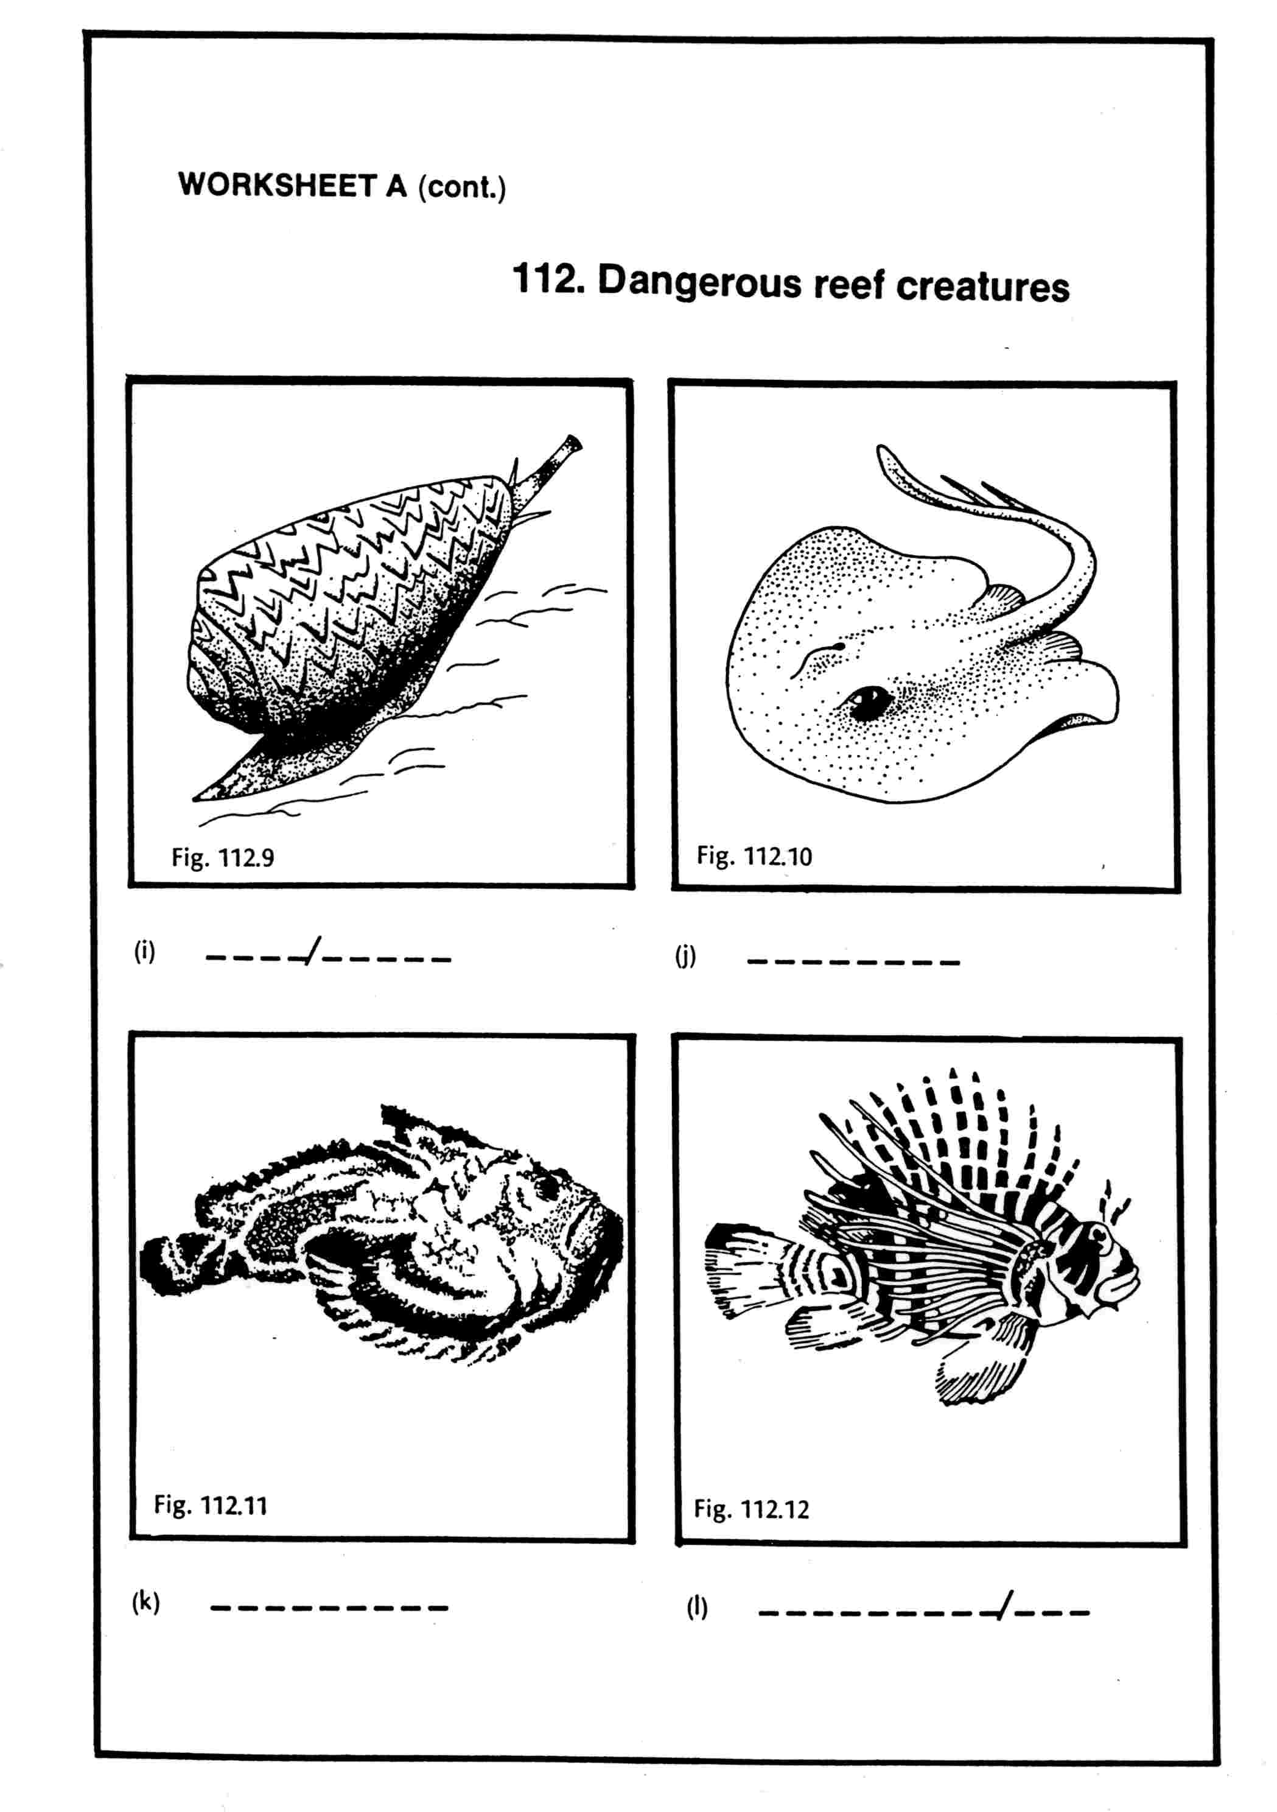

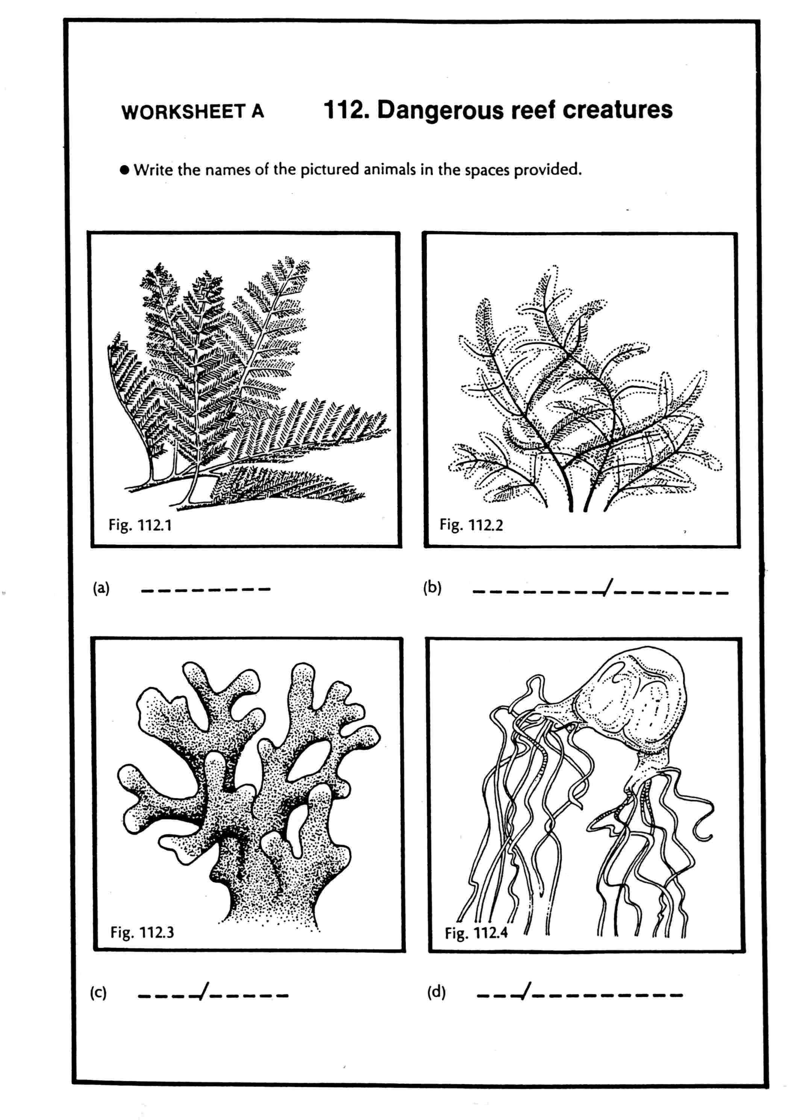

WORKSHEET B: DANGEROUS REEF CREATURES

In each of the spaces below write an appropriate name from the range of animals illustrated on worksheet A.

- Molluscs which inject venom using a harpoon _ _ _ _ / _ _ _ _ _ _

- Red-and-white fish which sting using venomous spines _ _ _ _ _ _ _ _ _/ _ _ _

- Feathery white animals whose polyps contain stinging cells _ _ _ _ _ _ _ _ / _ _ _ _ _ _ _ _

- Hard brown-coloured colonies with yellow, smooth tips _ _ _ _ / _ _ _ _ _

- Bottom-dwelling fish with venomous barbs on whip-like tail _ _ _ _ _ _ _ _ _

- Plagues of these echinoderms have occurred
at some reefs _ _ _ _ _/_ _/_ _ _ _ _ _/ _ _ _ _ _ _ _ _

- Animals which dwell on the surface of the sea and which
are hazardous in northern parts of the Great Barrier Reef
area in summer months _ _ _/_ _ _ _ _ _ _ _ _

- Material from the slimy outside of these animals
must not be allowed to get into your eyes _ _ _/_ _ _ _ _ _ _ _ _

- These dull-coloured fish are well camouflaged.
Wear stout shoes when reef-walking. _ _ _ _ _ _ _ _ _

- Khaki animal colonies which look like brown clumps of fern _ _ _ _ _ _ _ _

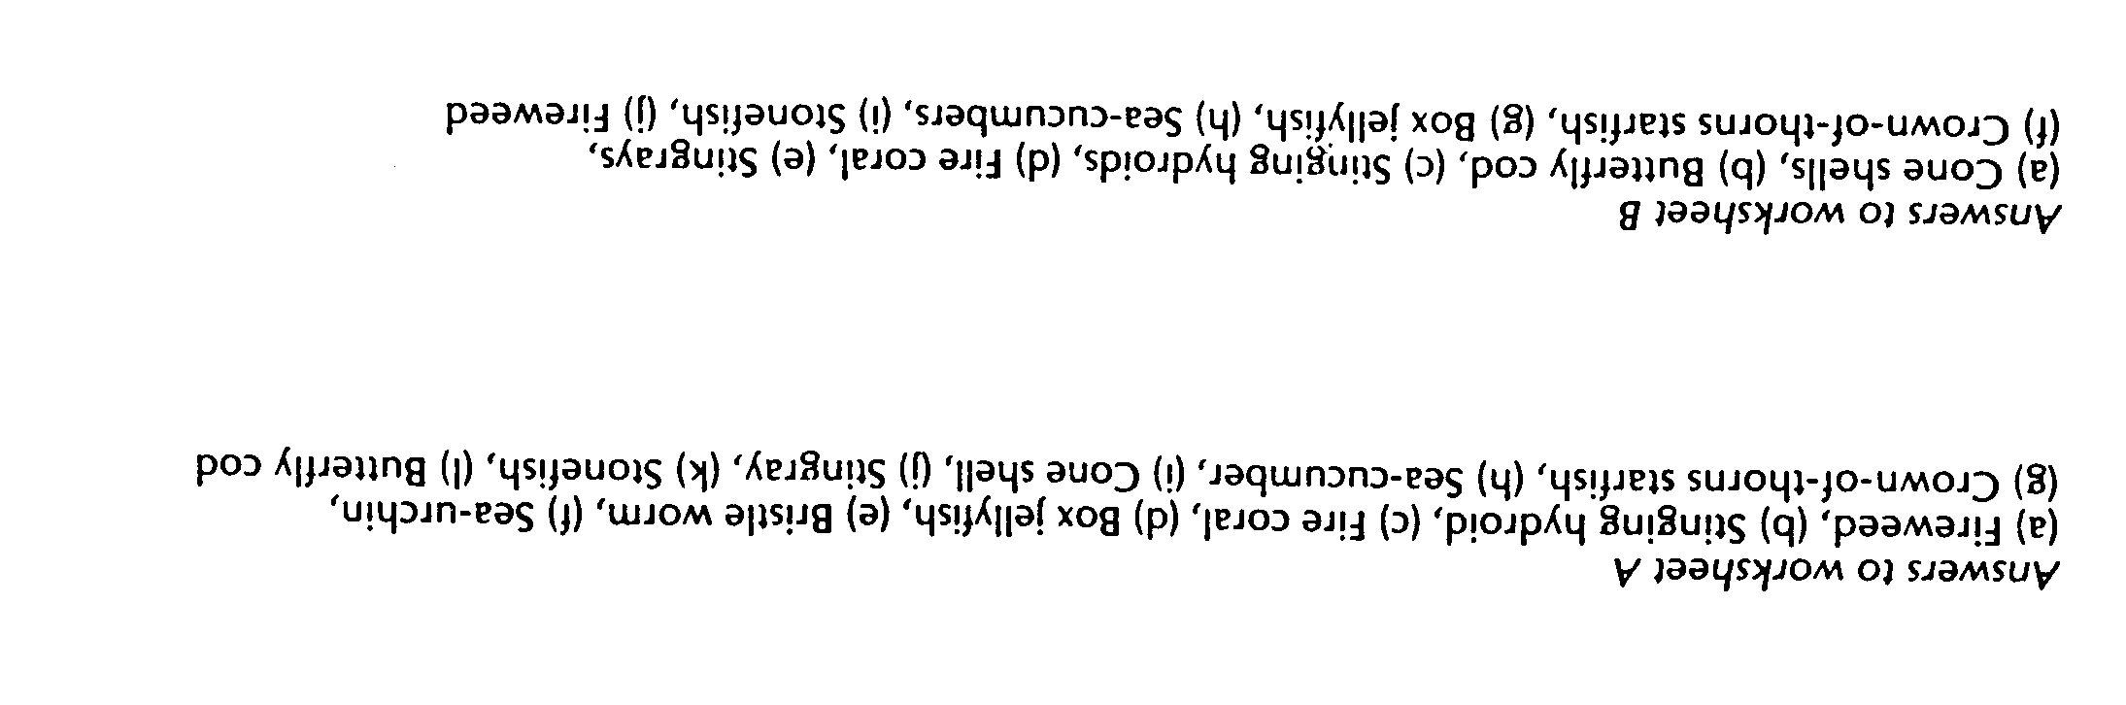
INDIVIDUAL ACTIVITY A: FOLLOWING A FRIENDLY FISH

Aim

- To investigate the lifestyle of a single fish

This activity consists of two parts – an introductory exercise and an in-depth exercise for those who wish to investigate their fish further.

You will need

- Snorkelling gear and appropriate protection from sun

What to do

Select one fish, which you can observe carefully. (A parrotfish, butterfly fish or puffer fish is suggested.)

- Observe its general structure. Note its size; exact colour patterns, position of fins, shape and position of mouth. Draw your fish and record observations on the following page.

- Observe its:-

- method of locomotion (note: use of all fins, tail, etc)
- method of catching/obtaining food and ingesting
- method of perceiving and reacting to the environment
- sense of organs
- response to changes (waves/depth/other fish/other groups/you)
- special behaviour, eg. territoriality, special relationships (symbiotic, commensal, parasitic)

Record these observations in the table on the next page.
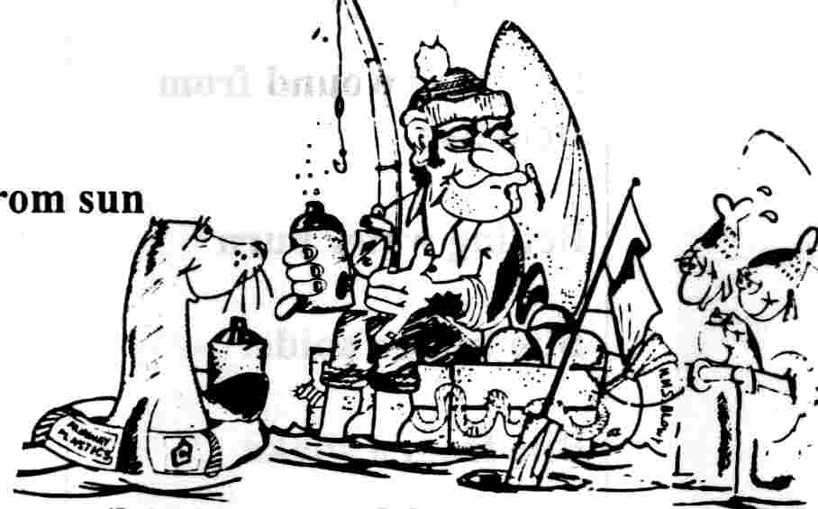

FISH INTERPRETATION (for part a)

POSSIBLE IDENTIFICATION: ___________________________ COMMON NAME: ___________________(GENUS)

Observations (part a)
___________________________________________________________
___________________________________________________________
___________________________________________________________
___________________________________________________________
___________________________________________________________
___________________________________________________________
___________________________________________________________
___________________________________________________________

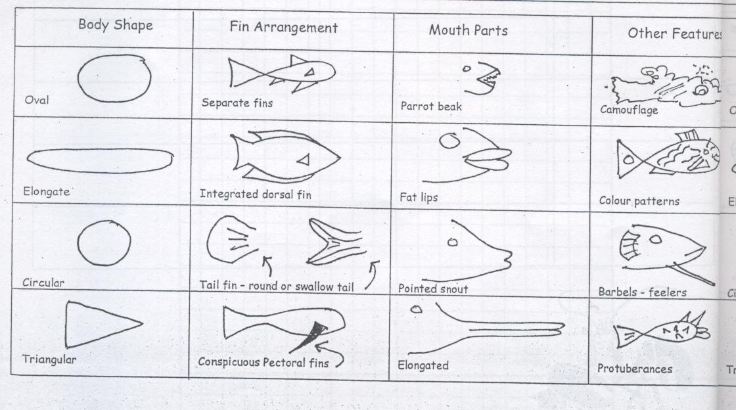

OBSERVATION TABLE (for part b)

FISH TYPE | OBSERVATIONS
Habitat
(among coral, close to coral, open water etc)

Feeding seen
(if any)

Type(s) of locomotion mostly observed
(stationary, manoeuvring, cruising, fast swimming)
When stationary:
Fins used
When manoeuvring:
Fins used
When cruising or fast swimming
Is movement of tail fin and body or movement of other fins more important?
Does the body and tail fin oscillate or undulate?

INDIVIDUAL ACTIVITY B: INTRODUCTORY NOCTURNAL STUDIES

AIM: To find out what a cay is like at night.
YOU WILL NEED: Sandshoes Torch

WHAT TO DO:
1. Walk around the cay at about 7.30p.m. noting crabs, turtles, mutton-birds, stingrays, sharks, spiders, luminous life, shells.
2. Depending on what you see, try to answer some of these questions:
(a) Ghost Crabs. Where are they going? What are they doing? What is their reaction to light? How do they behave when frightened? Are there different populations from one side of the island to the other? What was the biggest one you saw?
___________________________________________________________
___________________________________________________________
___________________________________________________________

(b) Luminous life. Look back at your footprints in the sand. Can you see glowing dots in the sand? Can you still see them when you shine the torch on them? Pick them up, observe with a hand lens. Who can find the largest and the brightest? Put them on your face, hands, arms. Make yourself a glowing skeleton. How long does each animal glow? Do different areas have greater abundance (wet sand, dry sand, north, south, east or west aspect)?
___________________________________________________________
___________________________________________________________
___________________________________________________________

(c) Reptiles and mammals. Can you find any land reptiles or mammals?
___________________________________________________________
___________________________________________________________

(g) Turtles. If you are lucky you will see either turtles laying or hatching. Describe their behaviour. What happens if torches are shined on laying or hatching turtles? Can your see any predators around?
___________________________________________________________
___________________________________________________________
___________________________________________________________

(h) Mutton-birds. How do they arrive back to the island? Are they affected by obstacles, or by light? How do they land? What social interactions occur amongst the birds on the island? How do they take off in the morning? How many take off at once? ___________________________________________________________
___________________________________________________________

