Pedagogical Framework
Inquiry Based Learning Framework 7 E’s
Introduction / Excitement
Orientation
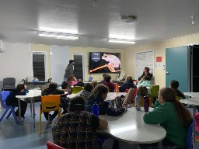
Engage
Questioning
Conceptualization
Explain
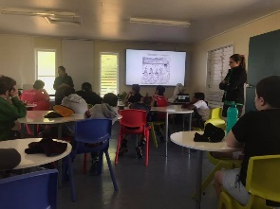

Investigation
Exploration
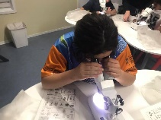
Experiential
Explicit

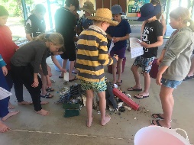
Elaborate
Data Interpretation

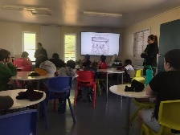
Conclusion
Discussion / Debrief

Evaluate

We Value the following:

Staff
- Wellbeing
- Collaboration
- Lifelong Learning
Woppaburra
- Elders
- Partnerships
- Projects
- Curriculum
- Language

Every Student Succeeding

Environment
- Respect Care and Concern
- Kanomi (NKI)
- Visiting schools
- Local/National/Global
Community
- P and C
- Weekend groups
- Educational
- Visiting Schools

Every Student Suceeding is in the centre and drives all other partnerships and values. Each of the valued groups all contribute to this.

Pedagogical Framework
Context:
North Keppel Island Environmental Education Centre (NKIEEC) is a Queensland Department of Education facility located 18km off Yeppoon. Currently, the QLD Department of Education has a 30 year lease on the centre. We employ 3 teachers, 1 principal, 2 cleaners, a teacher aide, a Boating Officer and Unit Support Officer.

Many groups visit the centre from all over Queensland. The blue drop pins on the map below give an indication of the variety of school groups that visit.

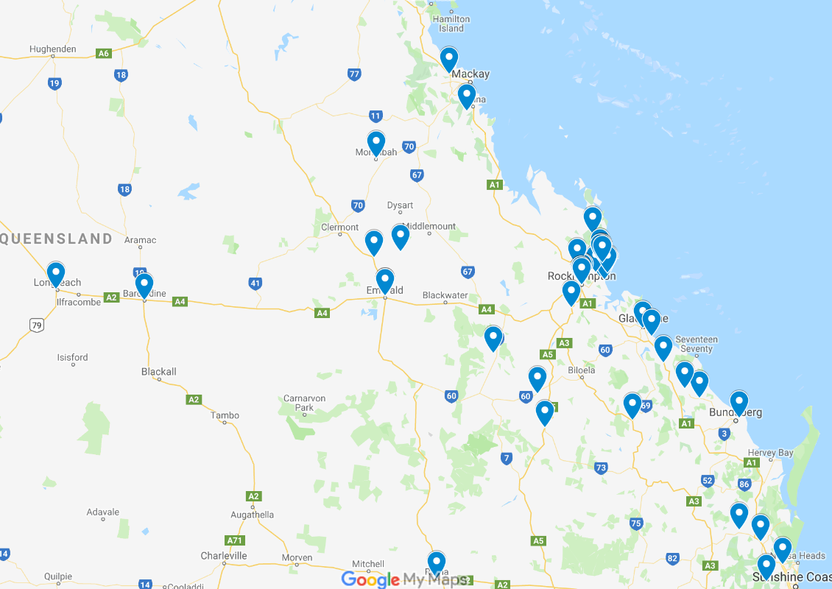

NKIEEC in 2020 had 35 Primary residential groups and 29 Secondary residential groups booked.
Predominently the secondary bookings are very focussed on the data collection for the relevant field studies for Marine Science, Geography and Biology, so only require the necessary activities that allow these schools to collect relevant data.
Primary and Lower Secondary groups however are the main focus of this Pedagogical Framework.

Research Based Framework
Introduction:
NKIEEC through consultation with visiting teachers and centre staff have adopted the Inquiry Based Learning Approach. Further refinement of this process included the wider community (P and C) and Traditional Owners (Woppaburra).

Inquiry Based Learning aspires to engage students in an authentic, discovery approach.
Before schools attend, visiting teachers are sent an A3 ‘roadmap’ that includes Inquiry Based questions that relate to the Australian Curriculum Indicators, General Capabilities and Cross Curriculum Priorities. (Appendix 1)
Visiting teachers then highlight the activities that they wish to complete on program and return it to the co-ordinator. NKIEEC staff then identify what Inquiry Based Questions and Australian Curriculum links need to be included in a program. These are then added into programs for NKIEEC staff, visiting staff and students as a basis for all lessons. (Appendix 2)

Why Inquiry Based Learning?:
Inquiry Based Learning emphasizes active participation and learner’s responsibilty for discovering knowledge that is new to the learner (de Jong & van Jooligen, 2008)
Through an exciting introduction and active questioning in the orientation and conceptualization phases students begin to take an active participation and through answering and further thinking, responsibility for acquisition of new knowledge. Deep questioning to guide students in learning helps them to take ownership of their learning and discoveries during a lesson at NKIEEC.

Lesson Structure
Through the study of many papers it was decided to work in the following structure of a lesson:
Orientation, Conceptualization, Investigation, Conclusion and Discussion.

Orientation focuses on stimulating interest and curiosity in relation to the problem at hand. During this phase the learning topic is introduced by the environment (Scanlon, Anastopoulou, Kerawalla & Mulholland, 2011) or given by NKIEEC staff.

Conceptualization is a process of understanding a concept or concepts belonging to the stated question. This type of questioning is a formulation of investigatble questions (White & Frederiksen, 1998). Thus the outcome of the Conceptualization phase are research questions to be investigated during the lesson.

Investigation is the phase where curiosity is turned into action in order to respond to the stated question (Scanlon et al 2011).

Conclusion is the phase in which the basic conclusions of a lesson are stated (de jong 2006a). In this phase learners address the original Inquiry Based Question, to demonstrate learning. Assessment during this phase is possible.

The 7Es
Previous to this model NKIEEC Pedagogical Framework focused around the 7Es. Engage, Explain, Explore, Explicit, Experiential, Elaborate and Evaluate. These were included on as an extra heading base. The reader will notice these are included on the right hand side. The inclusion acknowledges past pedagogies and how they can be included in future pedagogies as a possible sub phase, but not a main focus.

Summary
The main goal was to provide NKIEEC teachers a synthesisized Inquiry Based Learning framework from learners’ perspective that can be used to ensure an effective Inquiry Based Learning process.
A systemic literature review was conducted in order to identify the core features of the Inquiry Based Learning process and to synthesize a framework that combines the strengths of exsisting Inquiry Based Learning frameworks. It is expected that the use of the new framework extracted from the literature review can be the key to success in implementing Inquiry Based Learning at NKIEEC effectively.
References
deJong T (2006a) Technological advances in Inquiry Learning. Science 312,532-533.doi:10.1126/science.1127750
deJong T & van Jooligen, W.R (2008) Model facilitated Learning. In J.M Spector, M.D Merrill, J Van Merrienboer & M.P Driscoll (Eds) Handbook of research on educational communications and technology (3rd ed., pp457-468) New York: Lawrence Erlbaum
Scanlon, E., Anastopoulou, S., Kerawalla., & Muholland P (2011) How technology resources can be used to represent personal inquiry and support students’ understanding of it across contexts. Journal of Computer Asssisted Learning, 27, 516-529. Doi 10.1111/j.1365-2729.2011.00414.x.
White, B Y., & Frederiksen, J R (1998). Inquiry modeling and metacognition: making science accessible to all students. Cognition and Instruction, 16,3-118.doi10:1207/s1532690xci1601_2

