|  |
| --- |
| Assessment task — Creating a creature: Student resource 2 |

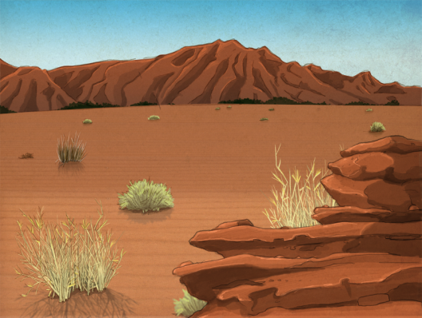Newly discovered environment  
  
