Survival in the environment | Year 5 | Unit 1
Assessment task — Creating a creature: Model response
Note: The examples provided are not the only possible answers in this task; they simply show the possible links between structural features and environmental conditions.
Task
Your task is to design two creatures and compare adaptations that allow each creature to survive in the environments provided. You will use a slideshow to present your creature and information.
- View the two environments on the assessment tasks Creating a creature: Student resource 1 (Island environment) and Creating a creature: Student resource 2 (Newly discovered environment) and examine the environmental data.
- View the different structural features on the assessment task Creating a creature: Student resource 3 (slideshow). You need to include the following when you create your creature (slides 4–14):
- Body type
- Head type
- Eyes
- Feet
- Tail type
- Use these structural features to create a creature with features that will help it survive in the:
- island environment
- newly discovered environment.
Copy and paste the images from the assessment task Creating a creature: Student resource 3 (slideshow) into your own slideshow.
- Add notes to your slideshow to:
- describe each creature’s structural features
- use the environmental data and your science knowledge to analyse how the features enable the creature to survive in its environment, e.g.
The creature has a long thin body type. It lives in a rocky environment and this feature would assist the creature to be able to hide under the rocks for protection from predators and sleep under the rocks for shelter.
Note: More than one slide for each creature and environment may be created to assist in the description.
Students should identify structural features and make links with the data supplied about each environment.
An example response for the creature in the desert environment would include:
- The creature has a body that is covered with tough leathery skin. It lives in a very hot climate and so its leathery skin would protect it from the sun. It also helps to prevent water loss through its skin.
- The creature has a small mouth. This feature is important in a hot environment as it means the animal will not lose as much water to the air through breathing.
- The creature has a long tongue. This feature will help the animal to catch insects in the environment and means it can do so quickly. It will be able to extend its tongue to catch insects that are at a distance.
- It has large eyes with long eyelashes. The desert has a lot of sand and the long eyelashes would offer protection from the fine sand as well as protection from the sun during the day. The large eyes would assist with their vision at night when the insects are more active.
- The creature has large, padded feet. The ground surface in the desert would be very hot as there is not a lot of ground cover and no canopy cover. The padding on the feet would protect the animal from hot ground surfaces and the large surface area of the foot ensures that the animal is less likely to sink into soft, sandy ground.
- It has a large thick tail. The desert is dry and hot and there is not a lot of food available. The thick tail allows for the storage of fat to provide it with energy during times when food is not available.
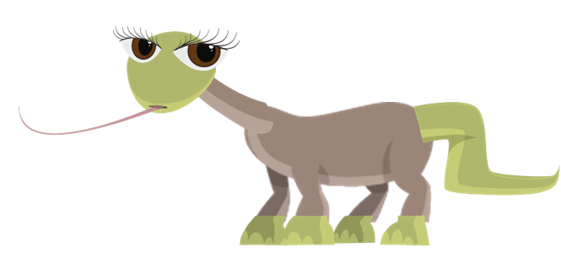
A similar response, listing different structural adaptations, would be expected for the creature in the island environment.
- Use the environmental data to justify the differences in structural features between the two creatures.
Student responses should not justify differences in structural features in terms of a cause and effect, or need’s-based relationship — the animal doesn’t have padded feet because the ground is hot or because it needs to keep its feet from getting burnt.
Student responses to this question should indicate how the different structural features help each of the animals survive in its own environment. For example:
The two environments vary greatly in the amount of canopy cover available. This has an effect on the air and ground temperature in each of the environments. This means that the same structural features would not help both animals survive in both environments. The newly discovered environment creature has tough, leathery skin and padded feet that protects it from the sun and hot conditions; whereas these features would not help the creature in the island environment. A warm, fur coat helps it survive in the cold, but would not help it survive in the newly discovered environment.
Different structural features help each of the animals to catch/collect the particular food that is available in each of the two different environments. The newly discovered creature will use its long tongue to catch the insects flying about; whereas, the creature from the island environment will use its long neck to help it reach the fish in the intertidal waters. Its long neck will also help it to get into hard to reach places to catch small animals for food.
- Predict how your creature would be affected if most of the trees were logged in the newly discovered environment.
Student responses need to identify behavioural changes that are in response to a change in the environment that impacts on the creature’s chances of survival e.g. its ability to get food.
Note: An individual animal cannot change its structural features in order to survive. Change in a structural feature of an entire species occurs over many generations and so would not be appropriate in this scenario.
For example:
Changes to the environment will affect how well my creature can get food, or keep its body functioning. It can’t change its structural features, but it may be able to make some behavioural changes so that it can continue to survive.
My creature has a furry body that keeps it warm in the cold environment. If there was a decrease in canopy cover, the air temperature would increase. The creature could change its behaviour to stop it overheating by moving to another shaded environment or by seeking other forms of shelter during the hot part of the day. It could also become more active at night to avoid overheating during the daytime. These behaviours would help it to survive.
My creature relies on intertidal water sources as they act as a habitat for the fish which are a food source. The water sources may become polluted due to ships dumping rubbish. This would reduce the availability of fish as a source of food. My creature could change its behaviour by eating other types of food, such as small animals under the rocks.
Note: If the animal would not be affected, this also needs to be justified.

