North Keppel Island Environmental Education Centre


Learning for Life

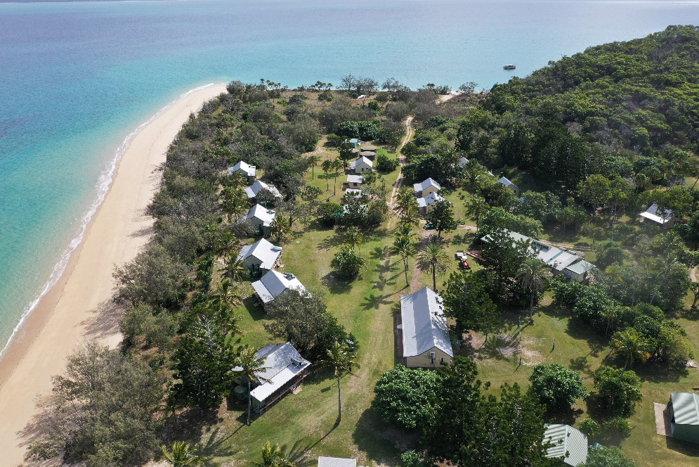

Social/Personal Development and Commitment to Program Report

Student: | Insert Student Name
School Teacher on program: | Insert School Teacher attending program
NKIEEC Principal: | Mr. Andrew Gill
North Keppel Island Environmental Education Centre reports each student’s social and personal development, as well as their commitment to the program while here at the centre. These observations are taken anecdotally throughout the program.

Social Development/Personal Growth and Learning Attitudes: KEY
Always | Your child demonstrates the relevant social/personal development or commitment all of the time.
Usually | Your child demonstrates the relevant social/personal development or commitment most of the time.
Sometimes | Your child demonstrates the relevant social/personal development or commitment some of the time.

 | North Keppel Island Environmental Education Centre

Social Development

 | Sometimes |  |  | Usually |  |  | Always
Demonstrates skills to work collaboratively | MON | WED | FRI | MON | WED | FRI | MON | WED | FRI
Practises skills to establish and manage relationships | MON | WED | FRI | MON | WED | FRI | MON | WED | FRI
Participates positively in groups and teams | MON | WED | FRI | MON | WED | FRI | MON | WED | FRI
Encourages others | MON | WED | FRI | MON | WED | FRI | MON | WED | FRI
Negotiates roles and responsibilities | MON | WED | FRI | MON | WED | FRI | MON | WED | FRI

Personal Development

 | Sometimes |  |  | Usually |  |  | Always
Explores how participation in outdoor activities supports personal health and wellbeing | MON | WED | FRI | MON | WED | FRI | MON | WED | FRI
Creates connections to natural and built environments | MON | WED | FRI | MON | WED | FRI | MON | WED | FRI
Demonstrates ethical behaviour and fair play that aligns with rules | MON | WED | FRI | MON | WED | FRI | MON | WED | FRI

Commitment to Program
 | Sometimes |  |  | Usually |  |  | Always
On time for activities | MON | WED | FRI | MON | WED | FRI | MON | WED | FRI
Organises themselves | MON | WED | FRI | MON | WED | FRI | MON | WED | FRI
Completes set tasks | MON | WED | FRI | MON | WED | FRI | MON | WED | FRI
Enthusiastic about activities | MON | WED | FRI | MON | WED | FRI | MON | WED | FRI

School Teacher on Program NKIEEC Principal

______________________ ______________________

