Name:
Unit 2 Biology Research Investigation Journal
There are 4 phases involved in completing a research investigation:
A research and planning phase where you
- select a claim to be evaluated
- identify the relevant scientific concepts associated with the claim
- pose a research question addressing an aspect of the claim
- conduct research to gather scientific evidence that may be used to address the research question and subsequently evaluate the claim
An analysis and interpretation phase to
- analyse the data to identify sufficient and relevant evidence
- identify the trends, patterns or relationships in the evidence
- analyse the evidence to identify limitations
- interpret the evidence to construct justified scientific arguments

A conclusion and evaluation phase to
- interpret the evidence to form a justified conclusion to the research question
- discuss the quality of the evidence
- evaluate the claim by extrapolating the findings of the research question to the claim
- suggest improvements and extensions to the investigation
A communication phase to present your findings in the form of a scientific essay. It will contain the following sections
- Title
- Research and planning (achieved by completing the following sections)
  - Claim
  - Rationale
  - Research Question
- Evidence, analysis and interpretation
- Conclusion and evaluation (achieved by completing the following sections)
  - Conclusion
  - Evaluation
- Reference list

Research and planning phase
How do we develop a research question from a claim?
There are 6 major steps in this process:
- Break down the claim
- Question the key elements of the claim
- Pose possible research questions
- Research specific elements
- Critique your possible research question
- Select and refine your research question

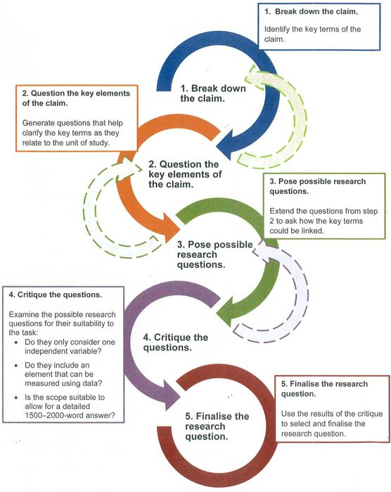

Developing a Claim
Steps Involved | Planning questions | Have sexually transmitted infections in Australia re-emerged as public health issues?
Find an article of interest | Could this article be used to generate a research question? | Can it be linked to the general claim? Does it reference other sources of information and does it present data?
- Break down the claim | What are the key elements (terms / phrases) in the claim? | ‘STI’, ‘re emerged’, ‘public health issue’
- Question the key elements of the claim | Write some questions that help clarify the key element of the claim.  Which key elements need to be more specific? | - Which STI?  - Has it re-emerged, have rates of infection increased?  - Is it a significant public health issue in Australia?
- Conduct research to gather information to address the refining questions | Write some statements out that could be developed further | - Which STI’s have increased their infection rates in Australia? Choose one.  - How has it re-emerged?  - How is it a public health issue?  - Has HIV re-emerged as a public health issue in urban Australia?  - Has HIV re-emerged as a public health issue in a specific place in Australia?
- Pose possible research questions | Extend the clarification questions regarding key elements above by linking some of these points together, after some further research | Possible research questions:  - Has HIV re-emerged as a public health issue in Australia?
- Research specific elements | Locate reputable reference sources and search for specific data that can be used as evidence to support / not support your research question. | - Wikipedia  - New Scientist  - Library texts/videos, Databases  Texts, journal or science magazine articles, government or University websites/publications.
- Critique your possible research question | Examine possible research question(s) for their suitability:  For the Research Question:  Has HIV re-emerged as a public health issue in Australia?  Note: this question is too broad | - Can only one of the key elements act as an independent variable? (e.g. Has HIV re-emerged in Australia?)  - Can quantitative data be gathered?  - Do the key elements need to be more specific?  - Should you specify a region or time frame for the question? (eg. Local- Australia or worldwide)  - Do you need to break down adverbs and descriptors to be more precise?  - Can data be presented in a table or graph and can it be analysed?  - Is the scope of the question appropriate? (for the specified word count)?
- Select and refine your research question | Ensure that the key elements of your final research question are specific. | Final Research Question:  ‘Has HIV re-emerged as a public health issue in Sydney?’

Developing Your Claim
Steps Involved | Planning questions | Claim
- Break down the claim | What are the key elements (terms / phrases) in the claim?
- Question the key elements of the claim | Write some questions that help clarify the key element of the claim.  Which key elements need to be more specific?
- 3. Conduct research to gather information to address the refining questions | Write some statements out that could be developed further
- Pose possible research questions | Extend the clarification questions regarding key elements (from step 3) by linking some of these questions together
- Research specific elements | Locate reputable reference sources and search for specific data that can be used as evidence to support / not support your research question.
- Critique your possible research question | Examine possible research question(s) for their suitability:
- Select and refine your research question | Ensure that the key elements of your final research question are specific.
- Final research question | Teacher approval checkpoint
Research Investigation format
Rationale (400-500 words)
Here you are outlining the choices or processes you went through in selecting and refining your Research question. These reasons should be justified (Supporting statements identifying research). It establishes the context of the claim.
You should put into words how your question was refined down from your initial broader question and justify how the research question is specific and relevant. This is where you could discuss a key article, study, organisation or company that is highlighting your claim. No data is discussed here.
Sentence Starters:
- There are several aspects to the investigation to be examined, especially ……
- The factors that contribute to this situation include ………
- The main reason that ……… occurs is ……
- The issue has had an impact on …..
- There are several reasons for ……..
Background (~ 300 words)
Here you discuss information surrounding your claim, including relevant definitions. It states how the research question is linked to the claim. Some explanation of theory may be required.
- ………. Has a number of distinguishing/notable features, including ……
- The key features of ……… are ……
- The most significant elements of …….. include ……….
Evidence ( ~ 500 words)
The biggest section, here you discuss the evidence you have found that supports your research question. You need to present quantitative and qualitative evidence referenced from respected science texts, magazines, science journals, university or government websites. Each piece of evidence you discuss must relate to the research question. There may be some evidence that contradicts your research question and this should be briefly introduced as it will be discussed further in the next section ‘Evaluation’.
The data you present must be analysed for patterns, trends and relationships. This data analysis must be related to the research question and support your conclusions. Include captioned tables and graphs.
Evaluation (~ 300 words)
Here you critically analyse (strengths and weaknesses) the quality of the evidence you have used. Try to extrapolate the research data to your claim, for example; ‘If Simpsons claim that 34% of patients suffered side effects from Diazepam is true then it is reasonable to consider that ….’. Consider the sampling techniques, sample size and random or systematic errors, were there repeated trials?
Here also you suggest improvements and extensions to your investigation that are relevant to the claim.
A good sentence starter might be; ‘Despite the overwhelming evidence supporting the research question there are some issues associated with Simpsons research techniques.’
Conclusion (~ 100 words)
A justified (provides links to key data or claims) conclusion that answers the general claim by answering the research question. If you can justify that your research question is supported, then so is the general claim.
Reference list
Consider using the Manage Sources application in the References tab found on the top ribbon in MS Word. This will enable you to construct your references/citations and bibliography quickly and easily in any format you need, please use APA format here at San Sisto.
You need to move away from the weak sources of information you may have used in junior high school and start to rely on more academic sources of information. Consider scientific magazines such as New Scientist, professional scientific journals, Biology text books and University or Government websites.
Wikipedia is a great place to start and provides many references you can use to research your subject. Do not cite Wikipedia in your text or reference list, use it to find primary sources of information such as scientific journals and data.
New Scientist is also a great place to start, your key article of interest from which you develop a research question might be found here. Logins; pwinter@bne.catholic.edu.au password; sansisto
The library webpage allows you to search any topic; suitable books and ClickView videos on your topic will be identified. If you enter your search words and select ‘Search other sources’ and select ‘Picture Australia’ you are taken to the National Library of Australia Database. In here select ‘Journals, articles and data sets’ and re-enter you search words. Ensure you tick the box under the search box for ‘available online’ so you can get the whole article of interest. This search will take you to the types of academically rigorous reference material you need.
We need less of this;
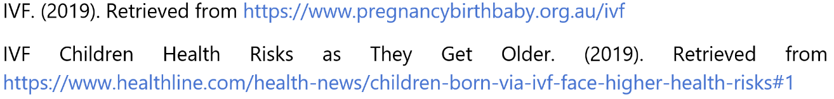
And more of this;
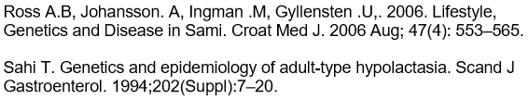
Checkpoints
Get your teacher to sign off each stage as you complete it
Term 2 Week 10: Select claim and develop research question.

Term 3 Week 1: Identify sources and conduct research.

Term 3 Week 2: Analyse and evaluate evidence.

Term 3 Week 3: Submit draft.

Term 3 Week 5: Submit final response.

